Newborn Jaundice

REFERENCES

1. [Kemper AR, Newman TB, Slaughter JL, et al. Clinical Practice Guideline Revision: Management of Hyperbilirubinemia in the Newborn Infant 35 or More Weeks of Gestation. Pediatrics 2022; 150.](https://www.uptodate.com/contents/jaundice-in-newborn-infants-beyond-the-basics/abstract/1)
2. [Dennery PA, Seidman DS, Stevenson DK. Neonatal hyperbilirubinemia. N Engl J Med 2001; 344:581.](https://www.uptodate.com/contents/jaundice-in-newborn-infants-beyond-the-basics/abstract/2)
3. [Maisels MJ, Bhutani VK, Bogen D, et al. Hyperbilirubinemia in the newborn infant > or =35 weeks' gestation: an update with clarifications. Pediatrics 2009; 124:1193.](https://www.uptodate.com/contents/jaundice-in-newborn-infants-beyond-the-basics/abstract/3)
4. [Ip S, Chung M, Kulig J, et al. An evidence-based review of important issues concerning neonatal hyperbilirubinemia. Pediatrics 2004; 114:e130.](https://www.uptodate.com/contents/jaundice-in-newborn-infants-beyond-the-basics/abstract/4)
5. [Maisels MJ, McDonagh AF. Phototherapy for neonatal jaundice. N Engl J Med 2008; 358:920.](https://www.uptodate.com/contents/jaundice-in-newborn-infants-beyond-the-basics/abstract/5)
6. [Sheridan SE. Parents of Infants and Children with Kernicterus. J Perinatol 2005; 25:227.](https://www.uptodate.com/contents/jaundice-in-newborn-infants-beyond-the-basics/abstract/6)
7. Bhutani VK. Public policy to prevent severe neonatal hyperbilirubinemia. In: Care of the Jaundiced Neonate, Stevenson DK, Maisels MJ, Watchko JF (Eds), McGraw-Hill, New York 2012. p.243.

[Neonatal Jaundice | PedsCases](https://www.pedscases.com/neonatal-jaundice)

[Hyperbilirubinemia](https://www.aap.org/en/patient-care/hyperbilirubinemia/)

[Clinical Practice Guideline Revision: Management of Hyperbilirubinemia in the Newborn Infant 35 or More Weeks of Gestation | Pediatrics | American Academy of Pediatrics](https://publications.aap.org/pediatrics/article/150/3/e2022058859/188726/Clinical-Practice-Guideline-Revision-Management-of)

[Technical Report: Diagnosis and Management of Hyperbilirubinemia in the Newborn Infant 35 or More Weeks of Gestation | Pediatrics | American Academy of Pediatrics](https://publications.aap.org/pediatrics/article/150/3/e2022058865/188725/Technical-Report-Diagnosis-and-Management-of)

[Neonatal Jaundice by L. Veit | OPENPediatrics](https://www.youtube.com/watch?v=rQ21vJmTDz4&t=38s)

[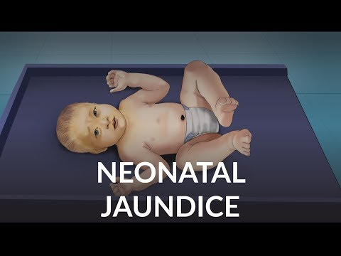](https://www.youtube.com/watch?v=rQ21vJmTDz4&t=38s)